# BACKUP DATABASE Ms Access

1. Open the Database that you want to create the backup copy of.
2. 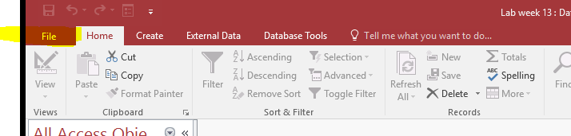Click the file tab.
3. Click SAVE AS.

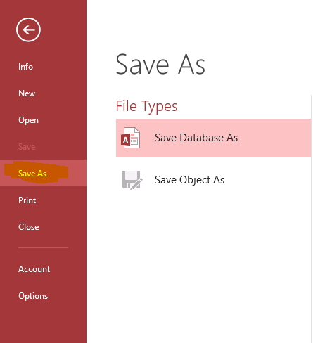

1. 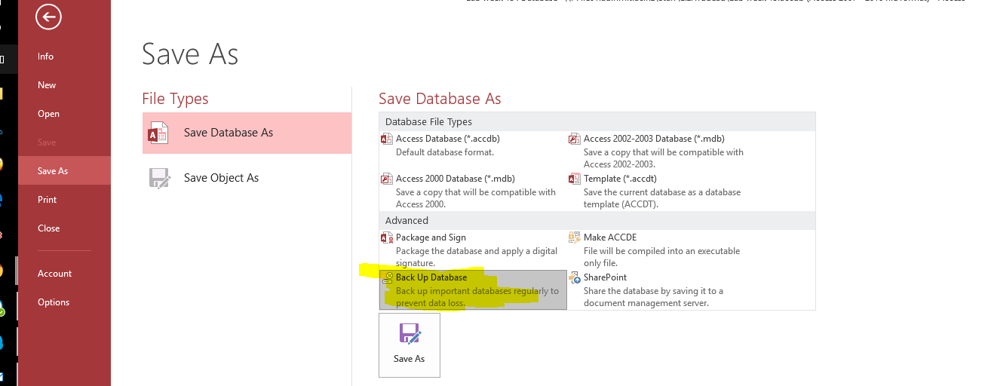In the SAVE AS area, under Advanced click BACK UP DATABASE.
2. Click SAVE AS button.

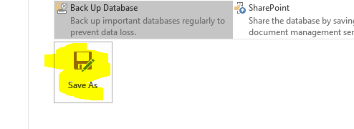

1. In the File Name box, review the name of your database backup.
2. 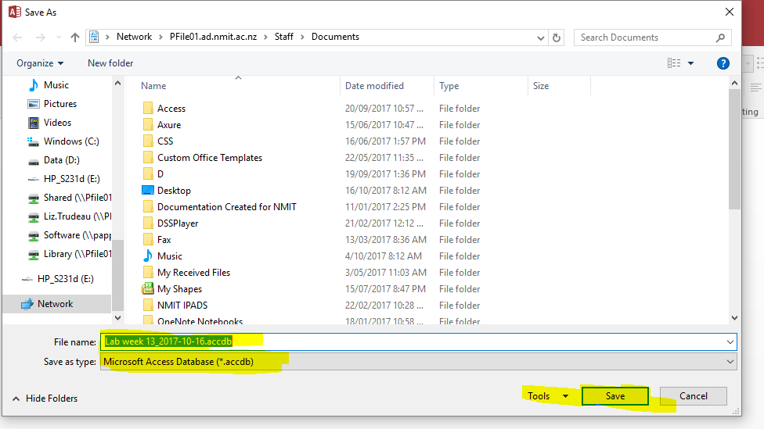Select file type from the SAVE AS type list and then click SAVE.